AI Impact on Job Market (2024–2030)
A Data-Driven Workforce Analysis

1. Problem Statement
With the rapid rise of Artificial Intelligence, industries are experiencing a major shift in job demand, skill requirements, and automation risks.
This analysis aims to answer:
- Which jobs are growing vs declining due to AI
- Which roles are at high automation risk
- Whether salary protects jobs from automation
- How job opportunities are distributed globally
👉 Goal: Understand how AI is reshaping the job market and what it means for future workforce planning.

2. Data Overview
- Dataset: AI Job Market Dataset (simulated/analysis dataset)
- Time Frame: 2024–2030 projections
- Key Fields:
  - job_title
  - job_status (Increasing / Decreasing)
  - growth_rate
  - automation_risk
  - risk_category (Low / Medium / High)
  - median_salary
  - location

3. Tools Used
Tool | Purpose
Python | Data cleaning & preprocessing
Power BI | Dashboard & visualization

4. Dashboard Overview
The dashboard is divided into 2 pages:

Page 1 — Market Overview
- Job status distribution
- Automation risk distribution
- Salary vs risk analysis
- Top 10 job growth comparison (2024 vs 2030)
- Job distribution by location

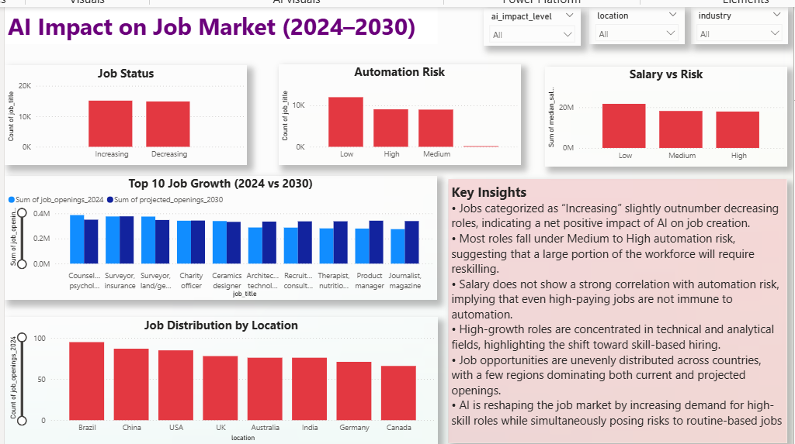

Page 2 — Job-Level Impact Analysis
- Top 10 fastest growing jobs
- Top 10 declining jobs
- Automation risk by job title

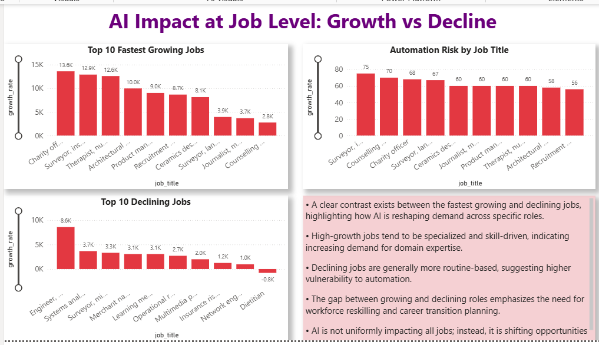

5. Key Findings

📊 Overall Market Trends
- Jobs classified as “Increasing” slightly outnumber decreasing roles, indicating a net positive impact of AI on job creation
- However, growth is not evenly distributed across job types

⚠️ Automation Risk
- Majority of jobs fall under Medium to High risk categories
- Indicates a large portion of the workforce will require reskilling

💰 Salary vs Risk
- High salary does NOT guarantee safety
- Even well-paid roles show significant automation exposure

🌍 Location Insights
- Job opportunities are unevenly distributed globally
- Certain regions dominate both current and future job openings

6. Job-Level Insights

🚀 Fastest Growing Jobs
- Growth is concentrated in:
  - Technical roles
  - Analytical roles
  - Specialized skill-based jobs
👉 These roles are AI complementary, not replaceable

📉 Declining Jobs
- Declining roles are:
  - More routine-based
  - Process-driven
  - Repetitive in nature
👉 These are highly vulnerable to automation

⚖️ Growth vs Decline Gap
- Clear gap between top growing and declining jobs
- Indicates structural shift in job demand

🔁 Workforce Shift Insight
- AI is not removing jobs completely
- It is shifting demand toward high-skill roles

7. Key Insights
- A clear contrast exists between fastest growing and declining jobs, showing how AI is reshaping job demand
- High-growth roles are skill-intensive and specialized, indicating rising demand for expertise
- Declining roles are routine-based and more vulnerable to automation
- Salary does not strongly protect jobs from automation risk
- AI is not eliminating jobs but shifting opportunities toward high-skill roles
- Reskilling and upskilling will be critical for workforce sustainability

8. Conclusion
AI is driving a transformation, not destruction, of the job market.
While new opportunities are emerging, they require:
- Higher skills
- Adaptability
- Continuous learning
Organizations and individuals who invest in reskilling will benefit the most, while those relying on routine work are at higher risk.

